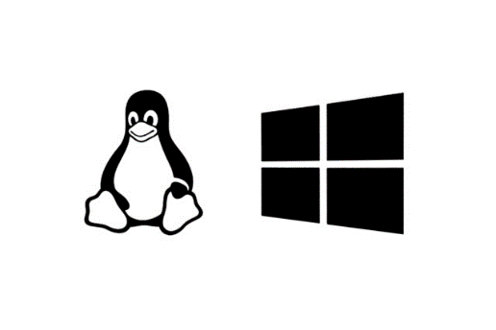

Buff Penguin Linux Beginners Workout

Need a quick workout for practicing your Linux skills? Fire up a Kali VM and get SWOL. Using these commands, in this order as a “set” will reinforce how they work as you nail the basics of the command line. Each command has an English translation next to it, with memorization cues and hints, as needed. So, grab a water bottle, fire up a terminal connection and let’s get busy!

**whoami –** “What user am I logged in as right now?” **WhoAmI**

**pwd** – “Where are we right now?” **P**rint **W**orking **D**irectory */root is the Superuser’s home directory*.

**ls** – “What is here, in this directory?” **L**i**S**t

**cd Documents** – “I want to move to the Documents directory” **C**hange **D**irectory

**ls** – “What is in the Documents directory? Probably not much.”

**touch testfile** – “Make a new, blank file named testfile in the current (Documents) directory.”

**ls** – “Hey, there is a new file in Documents named testfile, cool.”

**cat testfile** – “Show the contents of the testfile file. Huh, it is empty.” **Cat** is short for con**cat**enate.

**echo Sample Text >> testfile** – “add the words Sample Text to the testfile” *one > will replace the text.*

**cat testfile** – “Now testfile has the Sample Text in it.”

**mv testfile .testfile** – “I want to rename testfile as .testfile to hide it.” **M**o**V**e the text to a new file.

**ls** – “testfile disappeared!” *Somehow our file is hiding behind a single dot.*

**ls -a** – “Found it, that was not really well hidden.” **L**i**S**t **-A**ll contents, even hidden.

**rm .testfile** – “We deleted the .testfile.” **R**e**M**ove

**ls** – “Indeed, .testfile is no more.” *R.I.P. testfile today 2023 - today 2023, you served us well.*

**clear** – “clear the screen of old text.” Also **CTRL + L** if you want to save a bit of typing.

**uname -a** – what version of Linux are we running. (different flavors can use different commands)

**ip link** – what network links are on a system and are they up/up

**ping -c6 8.8.8.8** – Send six ping messages to check if you can reach the Internet server 8.8.8.8

**cd ~** - takes you back to your home directory.

**cp** – copy contents of x to y

**sudo !!** – run the last typed command with sudo level privileges

**cd ..** – “Let’s go back up a directory level” **C**hange **D**irectory

**history** – List of previously run commands. **!52** will run the command on line 52.